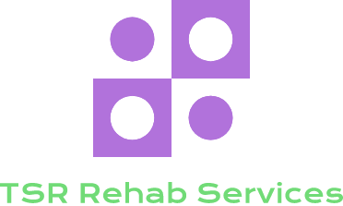
146 South Country Rd.
Suite 4
Bellport, NY 11713
Office: (631) 803-0738
Cell: (631) 805-1524
Email: tsrrehabservices@yahoo.com

PATIENT INTAKE FORM

Referring Physician_____________________________ Work Related Injury? Yes__________________ No_________________

How did you hear about us? _____________________ Do you have a pacemaker? Yes___ No___ Are you pregnant? Yes___ No___

Chief complaint:___________________________________________ When did the present symptoms start?___________________

In the past 3 months have you had any type of health care? Yes______________________________ No_______________________

If yes, please explain what type of services/intervention_______________________________________________________________

PATIENT INFORMATION

First name:________________________________ Last name:___________________________ DOB:________________________

Home address:_____________________________________ City:______________________________________________________

State:_______________ Zip code:_____________________ Home/cell phone number: _____________________________________

Email address: _______________________________________________________________________________________________

Employer address (if applicable)_________________________________________________________________________________

City:_________________________________ State: _______________Zip code:__________________________________________

Additional information (if any)___________________________________________________________________________________

EMERGENCY CONTACT PERSON

Primary:________________________________________________Relationship:__________________________________________

Phone: (home)___________________________________________cell:_________________________________________________

Secondary:______________________________________________Relationship:__________________________________________

Phone: (home)___________________________________________cell:_________________________________________________

INSURANCE INFORMATION

Primary Insurance Carrier:______________________________________________________________________________________

ID#__________________________________________ Group#________________________________________________________

Secondary Insurance Carrier:____________________________________________________________________________________

ID#__________________________________________ Group#________________________________________________________

PAIN DIAGRAM AND VISUAL ANALOG SCALE
Please read carefully:
Mark the areas on the diagram below that coincide with your pain. Include all the affected areas. Use as many individual symbols as you’d like to describe the pain intensity.
Indicate radiation of pain by drawing an arrow ( ) from the origin of pain to where it stops.
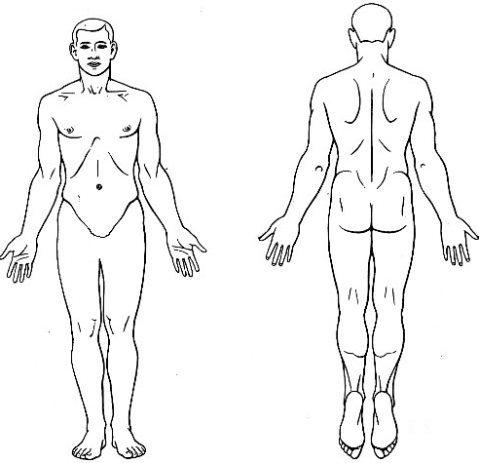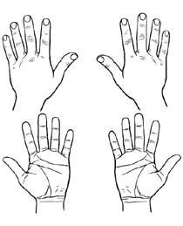

USE THE APPROPRIATE SYMBOL(S) LISTED BELOW.

ACHING XXXX NUMBNESS ==== PINS AND NEEDLES 0000
BURNING >>>> STABBING / / / / THROBBING + + + +
Circle the number corresponding with the intensity of your symptoms. A “0” = No Pain where as a “10’ = most severe pain imaginable.
Location:___________________________________________________________________0 1 2 3 4 5 6 7 8 9 10
Location:___________________________________________________________________0 1 2 3 4 5 6 7 8 9 10
Location:___________________________________________________________________0 1 2 3 4 5 6 7 8 9 10
Location:___________________________________________________________________0 1 2 3 4 5 6 7 8 9 10

INFORMED CONSENT FOR OCCUPATIONAL/PHYSICAL THERAPY TREATMENT AND SERVICES
By reading and signing this form, I hereby request and consent to the performance of Occupational and or Physical Therapy, including various modes of modalities, on me (or on the patient named below, for whom I am legally responsible) by the qualified therapy staff at TSR Rehab Services and/or who now or in the future work at TSR Rehab Services.
Although Occupational/Physical Therapy is considered to be one of the safest, most effective forms of therapy for musculoskeletal/neurological problems and pain, I am aware that there are possible risks and complications associated with these procedures such as Soreness: I am aware that with exercise, it is common to experience muscle soreness in the first few treatments. Dizziness: Temporary symptoms like dizziness and nausea can occur but are relatively rare. Fractures/Joint Injury: I further understand that in isolated cases underlying physical defects, deformities or pathologies like weak bones from osteoporosis may render the patient susceptible to injury. When osteoporosis, degenerative disk, or other abnormality is detected, this office will proceed with extra caution. Stroke: Although strokes happen with some frequency in our world, strokes from therapy treatment is extremely rare. I am aware that nerve or brain damage including stroke is reported to occur once in one million to once in ten million treatments. One in a million is about the same chance as getting struck by lightning. One in ten million is about the same chance as a normal dose of aspirin or Tylenol causing death. Occupational/Physical Therapy Burns: Some of the modalities used in this office generate heat and may rarely cause a burn. Despite precautions, if a burn is obtained, there will be a temporary increase of pain and possible blistering. This should be reported to the doctor. With signing this form, I freely consent to any therapeutic modalities that may be used to improve my health and well-being, decrease discomfort and decrease pain.
TREATMENT RESULTS
I also understand that there are beneficial effects associated with these treatment procedures and modalities including decreased pain, improved mobility and function, and reduced muscle spasm. However, I understand there is no certainty that I will achieve these benefits. I understand that the practice of therapy, is not an exact science and I acknowledge that no guarantee has been made to me regarding the outcome of these procedures and/or modalities. I agree and consent to the performance of these procedures and/or modalities by the qualified therapy staff at TSR Rehab Services.
We are required, by law, to maintain the privacy and confidentiality of your protected health information and to provide our patients with notice of our legal duties and privacy practices with respect to your protected health information. If Applicable, we may disclose your health information, as deemed necessary by law, to: comply with state Workers’ Compensation Laws, in cases of medical emergencies, to aid public health agencies such as the CDC and FDA, Governmental agencies as required by law, law enforcement officials and to comply with a court order, or to proper authorities as recognized by the state in order to assure public safety. Your rights include the ability to request (only) restrictions on certain uses and disclosures, to receive protected information by alternate means or at an alternate location, to have your physician amend your protected health information or file a statement of disagreement with you physician, and to receive an accounting of certain disclosures your physicians have made (if any). A more detailed explanation of these rights and responsibilities is readily available by us upon request, or at www.hcfa.gov/medicaid/hippa. Questions, concerns, and/or complaints should be directed to DHHS, Office of Civil Rights 200 Independence Ave., S.W. Room 509F HHH Building in Washington, DC 20201
I have read or have had read to me the above explanation of Occupational and/or Physical Therapy treatment and services at TSR Rehab Services. Any questions I have had regarding these procedures and/or treatment have been answered to my satisfaction Prior To My Signing This Consent Form. I have made my decision voluntarily and freely. To attest to my consent to these procedures, I hereby affix my signature to this authorization for treatment.
Patient Name___________________________________ Signature__________________________________________________
Date______________ Witnessed (and/or translated) by __________________________________________________________

